

Assignement One – RDBMS Practice Part II

Michael G Masterson



COSC 471 Section 0

E00942993

mmaster8@emich.edu

1. To execute the program, you will need to have Eclipse or a java compiler and the JDBC jar file. Each scenario, SQL Challenges, will need to be comment in or out the section. After you can run the program and then it will display your query results.
2. Some of the design issues that I had was that the queries didn’t want to work and kept throwing errors and it didn’t say where was the errors even thought I looked through the code to see where the error was. Another design issue was that in the Resources folder on the site there was two Chinook databases so it was difficult to see which one it was. Finally, going back and forth between the DB Browser for SQLite and seeing all the tables and columns and going back to Eclipse to write the queries.

1.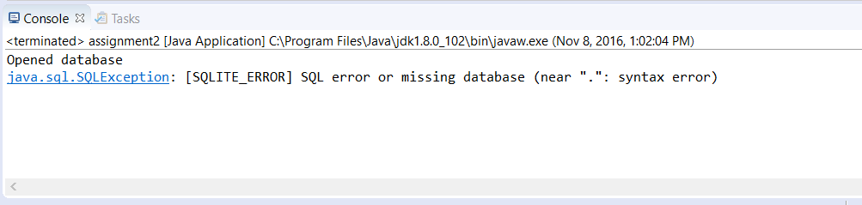

2.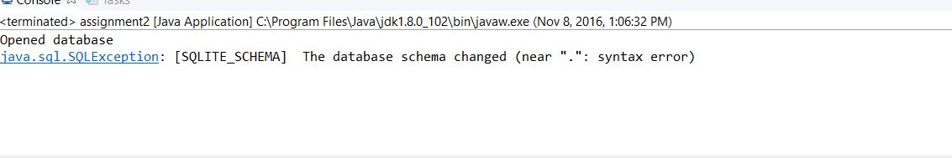

3.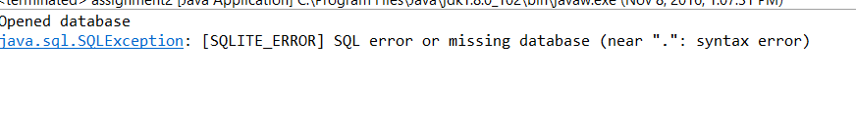

4.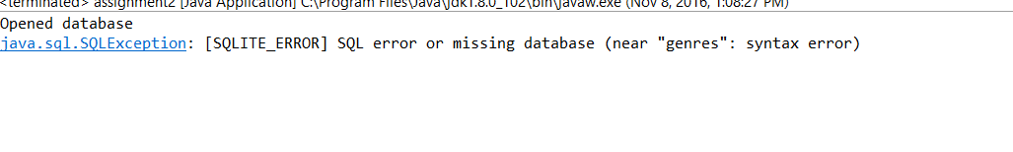

5.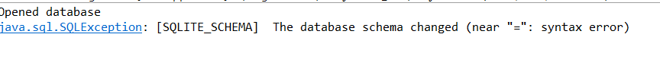

6.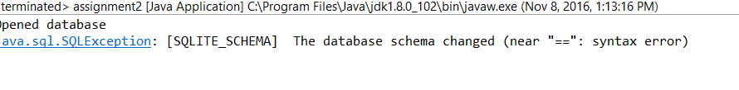

7.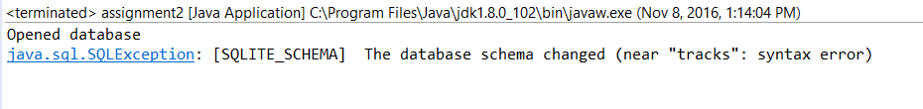

8.